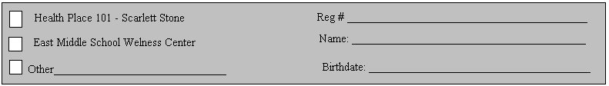
Physical Activity and Nutrition Group/Health Smart
(1=excellent, 2=good, 3=moderate, 4=minimal, 5=poor)

Physical activity during group:__________________________________

Effort/participation in physical activity:_____
Listening:_____
Interacted with peers:_____

Nutrition topic covered:________________________________________
Participation in nutrition discussion:_____

Signature:____________________________________ Date:_______________________

---------------------------------------------------------------------------------------------------------------------

Physical activity during group:__________________________________

Effort/participation in physical activity:_____
Listening:_____
Interacted with peers:_____

Nutrition topic covered:________________________________________
Participation in nutrition discussion:_____

Signature:____________________________________ Date:_______________________

---------------------------------------------------------------------------------------------------------------------

Physical activity during group:__________________________________

Effort/participation in physical activity:_____
Listening:_____
Interacted with peers:_____

Nutrition topic covered:________________________________________
Participation in nutrition discussion:_____

Signature:____________________________________ Date:_______________________

